Project 2025
Database used – Pizzas.csv
Software used – SSMS 2022
Data range - 2015-01-01 to 2015-12-31
KPI
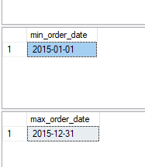
Query to generate Total revenue
select SUM(total_price) as Total_Revenue from pizza_sales
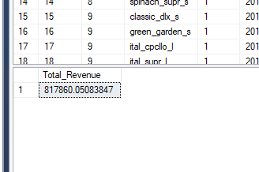
Query to generate Average order value
select SUM(total_price)/count(distinct(order_id)) as Average_order_value from pizza_sales
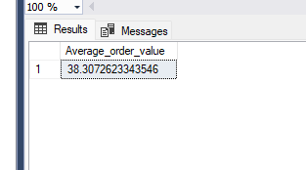

Query to generate total pizzas sold during the given time duration
select sum(quantity) AS total_pizza_sold from pizza_sales
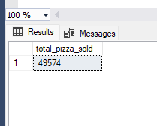
Query to calculate total no of orders placed
select COUNT(distinct order_id) as Total_orders from pizza_sales
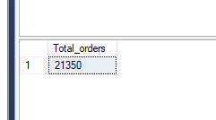

Query to calculate average pizzas per order
select CAST(CAST(sum(quantity) as decimal(10,2))/ cast(count(distinct order_id) as decimal (10,2)) as decimal(10,2)) as average_pizza_per_order from pizza_sales
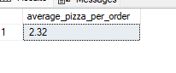

Charts

Daily trend for chart order – query to calculate daliy orders placed on all the days of the week and calculate total number of orders place each week day
select DATENAME(DW, order_date) as order_day,
COUNT( DISTINCT order_id) as total_orders
from pizza_sales
group by DATENAME(DW, order_date)
order by total_orders DESC
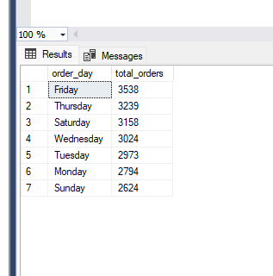
Hourly trend of pizza order – Query to calculate the hourly trend of pizzas ordered throughout the day by calculating pizzas sold each hour
select DATEPART(HOUR,order_time) as order_hours,
COUNT( DISTINCT order_id) as total_orders
from pizza_sales
group by DATEPART(HOUR,order_time)
order by DATEPART(HOUR,order_time)
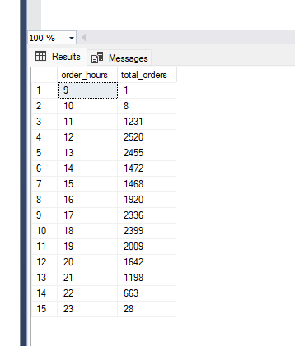

Percentage of sales per pizza category -
Query to calculate percentages of pizzas sold per category per month where month is denoted by a number e,g 1 = january, 2 = february ..... so on
select pizza_category,
sum(total_price)*100/(select sum(total_price) from pizza_sales where month(order_date)=1)as total_sales_percentage,
SUM(total_price) as total_sales
from pizza_sales where month(order_date)=1
group by pizza_category

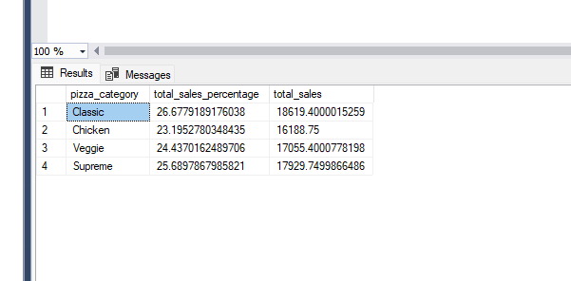

Percentage of sales per pizza size category -
Query to calculate percentages of pizzas size sold per category
select pizza_size, cast(sum(total_price)*100/(select sum(total_price) from pizza_sales) as decimal(10,2)) as total_sales_percentage,
cast(SUM(total_price) as decimal(10,2)) as total_sales
from pizza_sales
group by pizza_size
order by total_sales desc
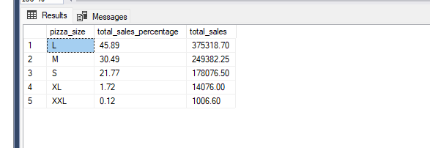

We can use where DATEPART(QUARTER, order_date)=4 before group by to gather quarter wise bifurcation
Total Pizzas sold per category -
Query to calculate total pizzas sold as per the category for the whole year
select pizza_category, SUM(quantity) as total_pizzas_sold
from pizza_sales
group by pizza_category
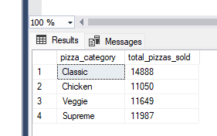

Top 5 Best sellers -
Query to calculate top 5 pizzas sold for the whole year
select TOP 5 pizza_name, sum(quantity) as total_pizzas_sold
from pizza_sales
group by pizza_name
order by total_pizzas_sold desc
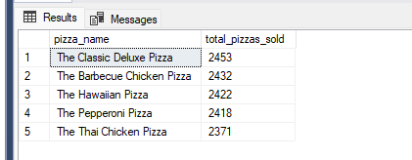
Top 5 worst sellers -
Query to calculate top 5 worst sellers for the whole year
select top 5 pizza_name, sum(quantity) as total_pizzas_sold
from pizza_sales
group by pizza_name
order by total_pizzas_sold
